
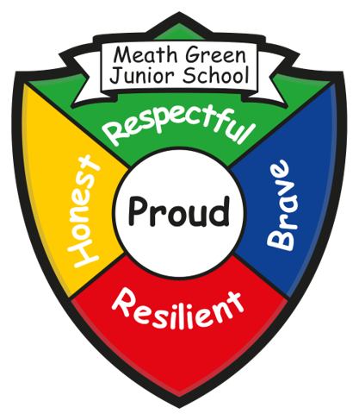
Meath Green Junior School
Autumn Newsletter
Greenfields Road, Horley, Surrey. RH6 8HW
Tel: 01293 784298 Website: www.mgjs.org
Email: info@mgjs.org
Headteacher: Mrs Serena Beasley (s.beasley@mgjs.org)
What’s been happening……
What a fantastic term this has been – already a third of the way through the academic year! It has been an absolute pleasure to be Headteacher! Having a very positive Ofsted visit where your children were highlighted as great pupils who absolutely love their school and embrace all the learning opportunities was so lovely to hear – but no real surprise. However, no foot off the pedal……we still have so much more to do! Your support has been very greatly appreciated – thank you for your kind words.
So, the festive spirit has certainly been at the forefront this December – the Christmas Fair, the Christmas Tree Carol Service at the Horley Methodist Church, Christmas Performances to name a few!
It is just left for me to say have a lovely Christmas holiday and a very happy New Year!
Thanks again – Mrs Serena Beasley

New entrance
We are really happy to let you know that from Spring term 2025 you will be able to use the newly refurbished entrance to the school. Whilst it is still not completely finished, we will be able to have access in and out of school. If you need to come to the school office this is the entrance you will need to use. Please avoid walking through the car park – use the gate and path that leads to the office. Thank you for your patience throughout this building project.
Goodbyes
We are very sad to say that Mrs Chester-Williams, our Forest Schools teacher, will be leaving this term. She has worked with so many children and has introduced them to the ‘great outdoors’. I know that you will join with us and thank her for the time and support she has given both the school and the children. We wish her all the best in the next stages of her adventure.
Christmas Fair
What an amazing event! Thank you to the Friends of MGJS for arranging and putting on such a great event. There was such a lovely buzz around the school. Thank you to all who helped to make it a success. From the Year 6 stalls, adult tombola, kids tombola, bucket raffle, name the Elf, cake sale, wooden Christmas craft, Christmas stalls, wrap a present for an adult, the Silent Auction and of course, Father Christmas. We were also lucky enough to have 500 Degrees Sliced Pizza Van and the Simply Crumble Van – delicious! Thank you for your support on the night – monies raised will ensure your children have access to some extra great learning resources and facilities.

Christmas Performances
Thank you for your support at our Christmas performances this year. The children really enjoyed all the different aspects of performing to you. A huge thank you to everyone who took part, the actors, the singers, the musicians with the support from Mrs Whitcher and of course, the staff. Through your generosity a total of £463.37 was collected for our chosen charities, Stripey Stork and Loveworks. This will make a difference for many children and adults in our locality so thank you!
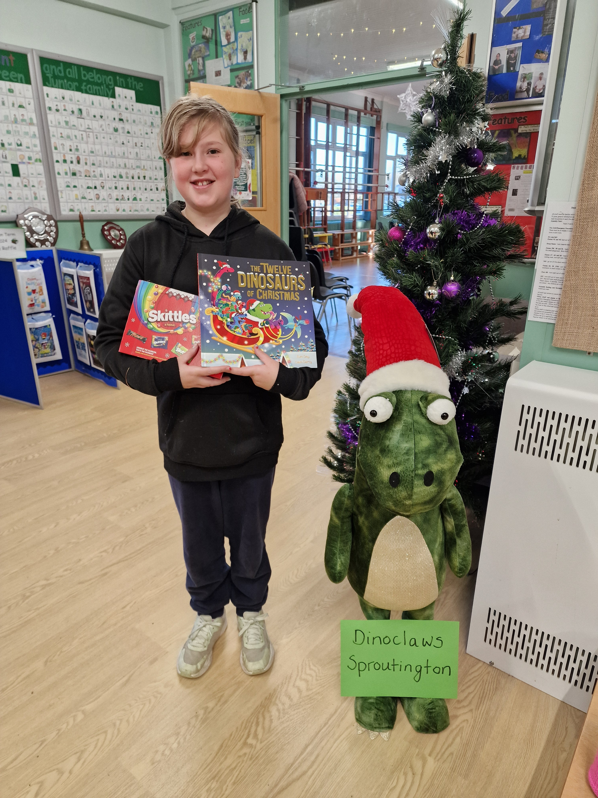
Name the Christmas Dinosaur
Congratulations to Abbygael in Year 6 and Mrs Scales in Year 5 for naming our Christmas dinosaur. The winning name is Dino Claws Sproutington. Well done to all others who had a go at the competition – some very interesting and creative names!
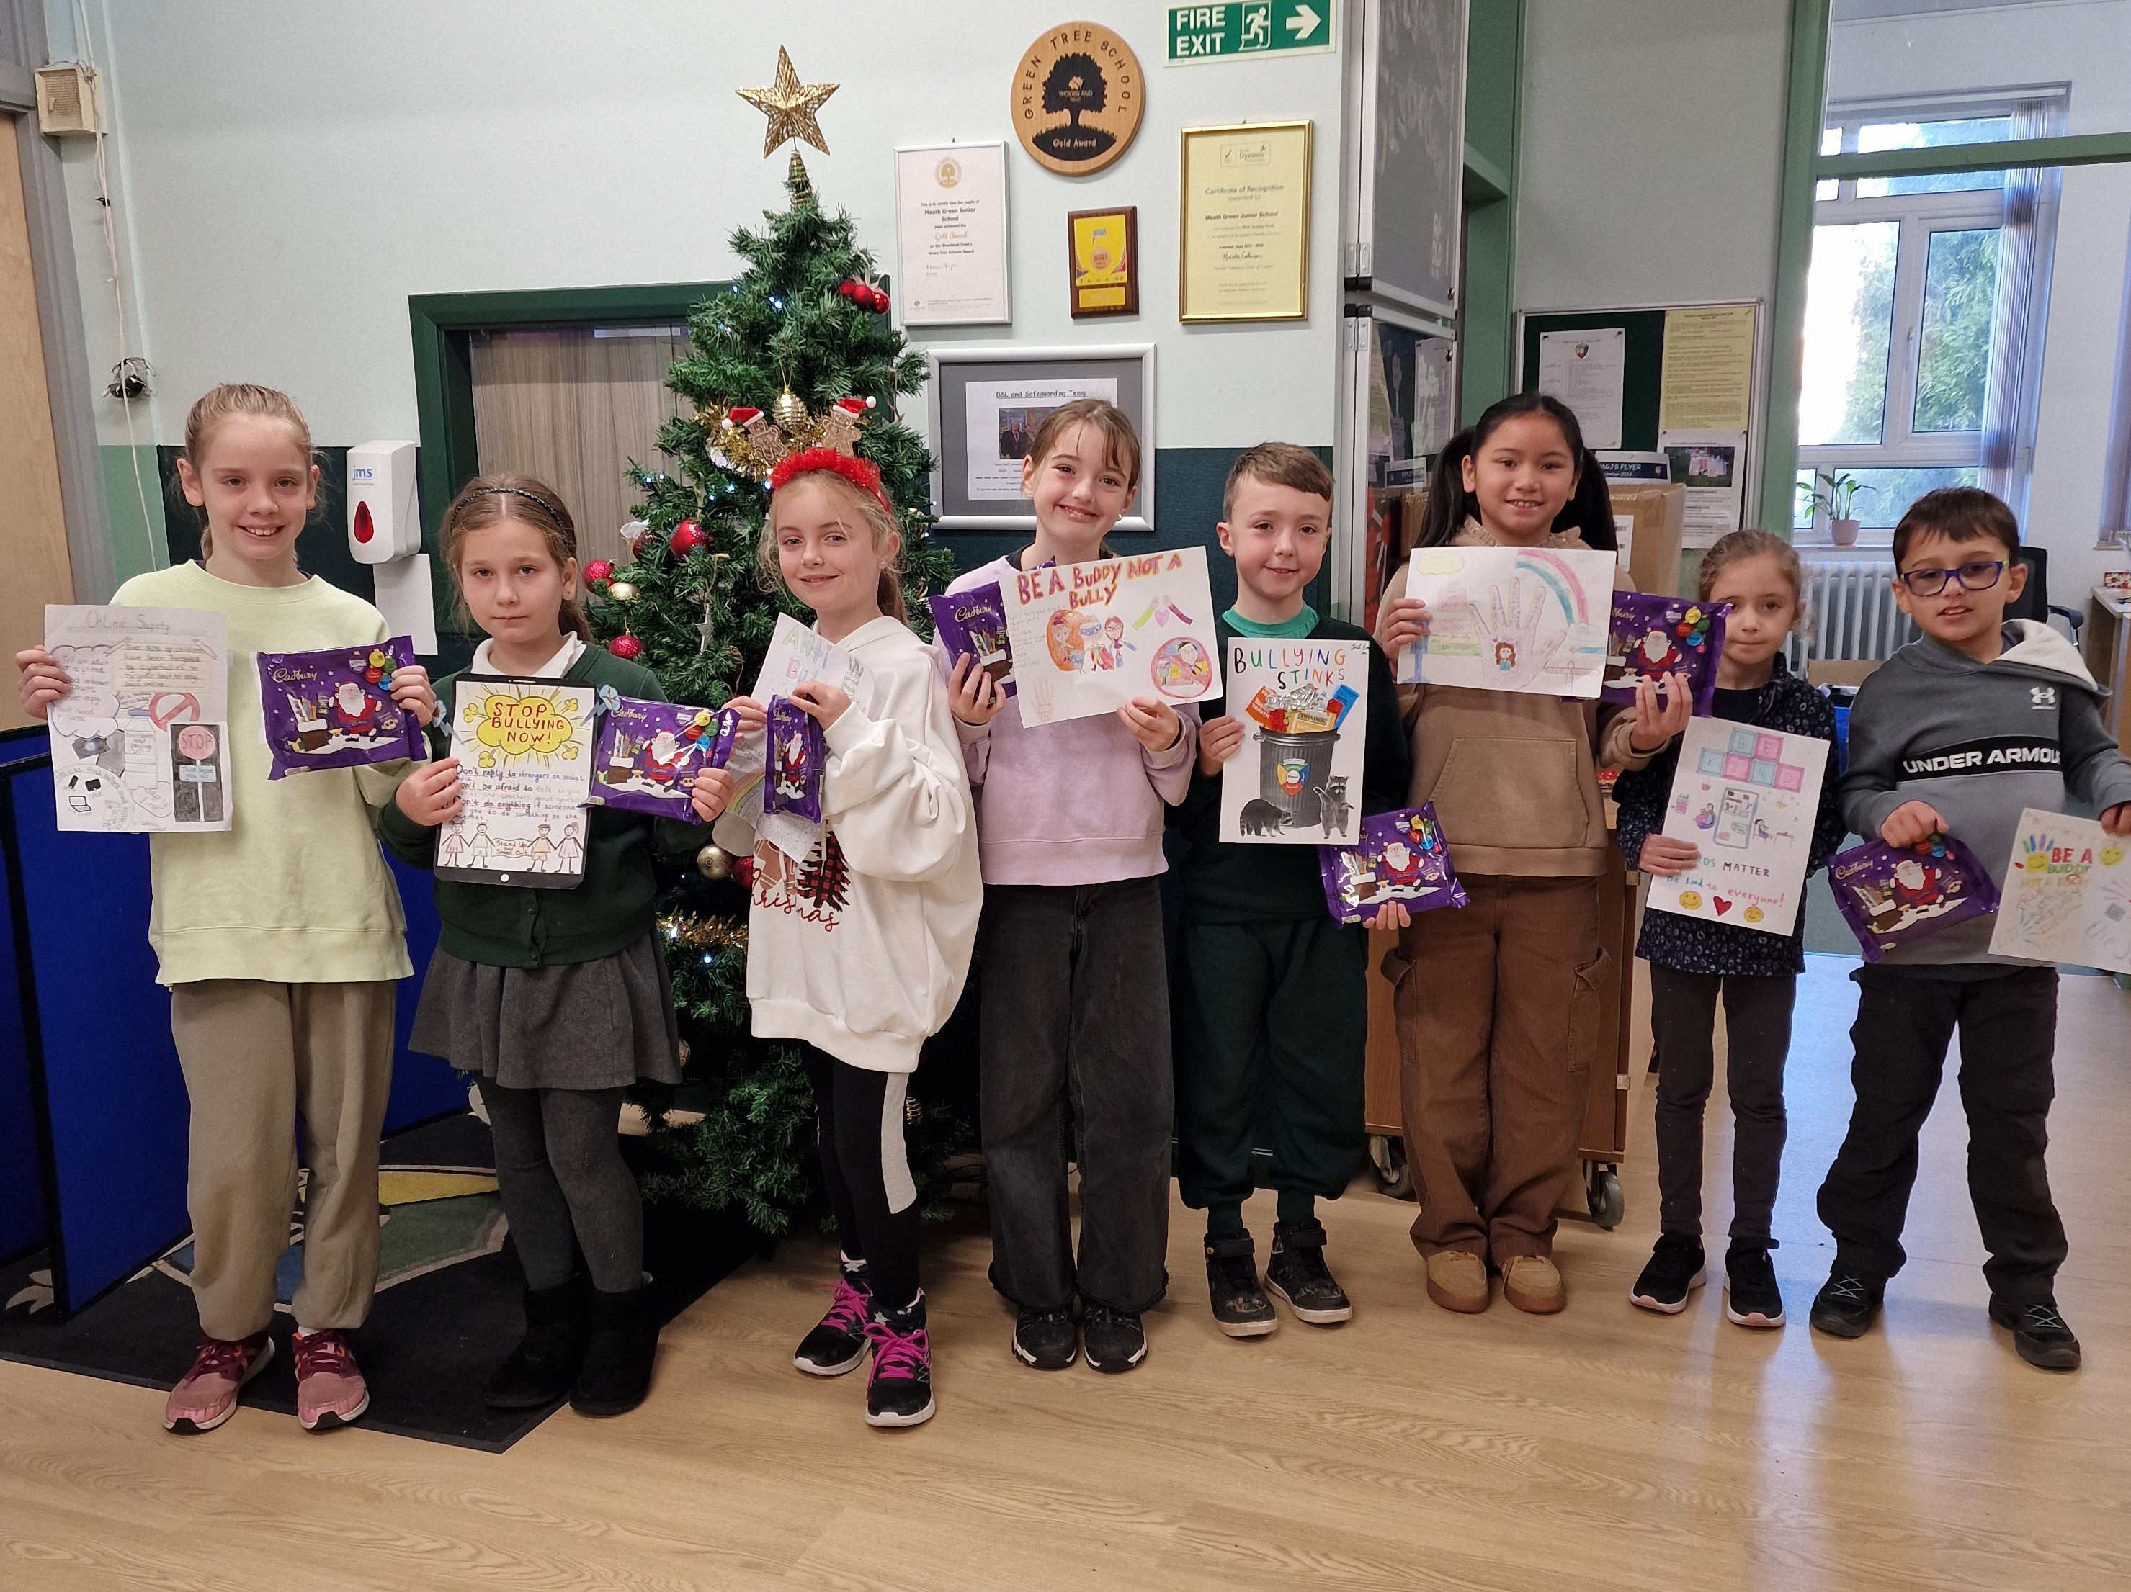

Anti-Bullying Week Poster Competition
Anti-Bullying Week this year had a focus on ‘choosing respect’ – this was great as it clearly links to our own school values. The week started with a whole school assembly, then there were individual year group assemblies and activities through the week. The Anti-Bullying posters were probably some of the best we have seen – thank you for your support at home with these. We had two winners from each year group and their posters will be proudly displayed around the school as a reminder that we are a school that does not tolerate bullying, either in person or on line.
Christmas Dinner Day and Christmas Jumper Day
There was a lovely festive mood in the hall on Christmas dinner day – happy smiling faces with Christmas music, Christmas hats and the like! Thank you to the kitchen ladies for the fabulous dinner, the dinner ladies for their hard work and all the staff who took time to spend lunch with the children. Again, it was great to see the huge variety of Christmas jumpers – a very colourful display! Hope the children enjoyed their lollypops donated by the Friends.

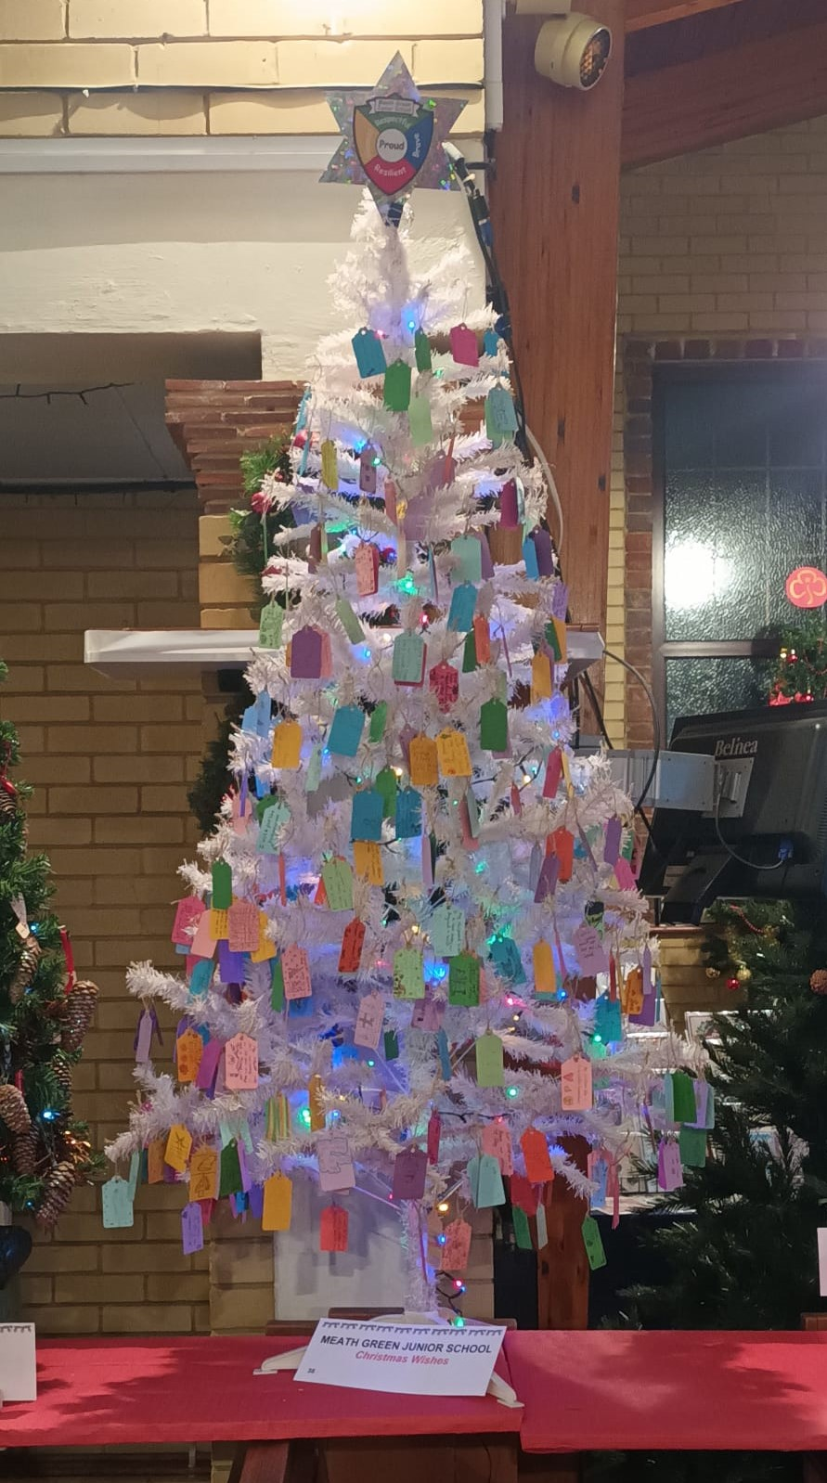
Christmas Tree Carol Service at Horley Methodist Church
Thank you to all who represented MGJS at the Christmas Tree Service at Horley Methodist Church. It was lovely to see all the Christmas trees, especially ours with ‘our wishes’. The pupils had a wide range of wishes this year from wishing everyone health and happiness, peace and happiness, lots of chocolate, a new dog! Many children just wanted to spend time with their families.
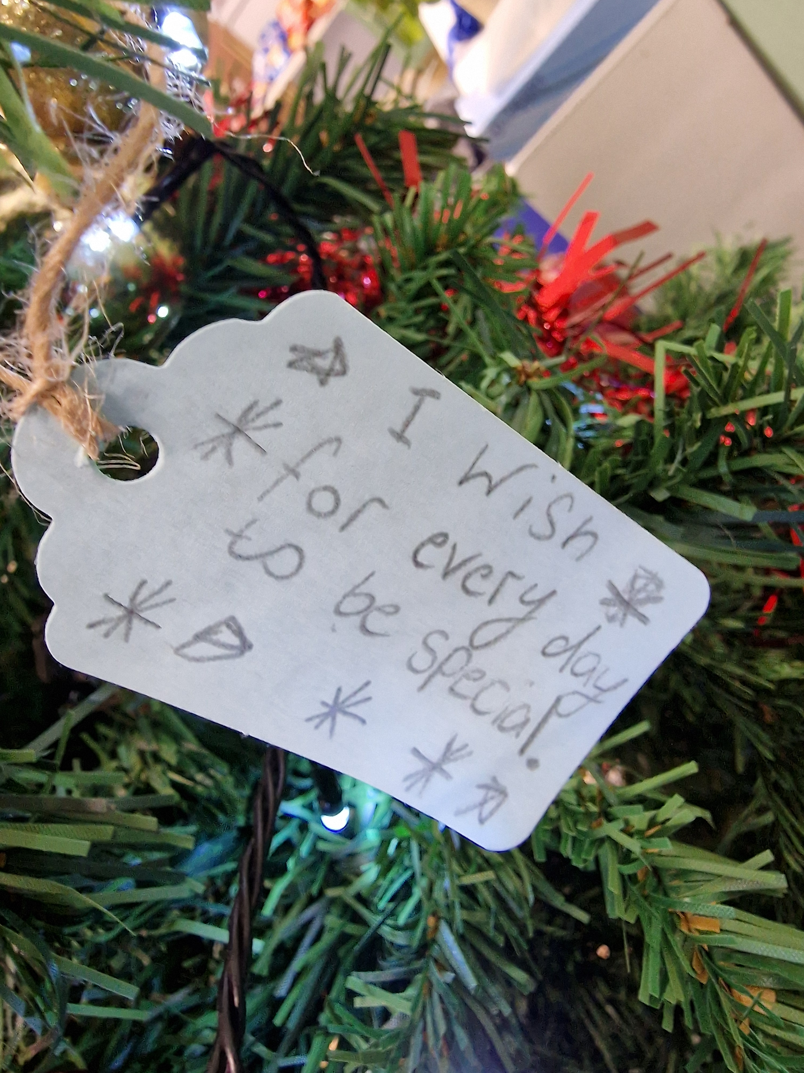
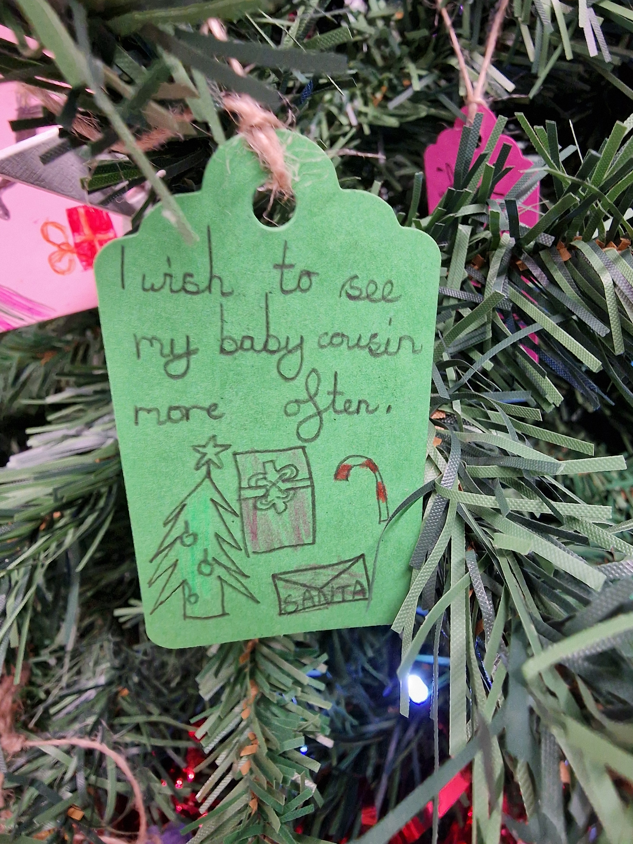

Year 3 Round-up of the Autumn term by Fox and Lucy
In September we started our new school MGJS. We were all feeling a bit shy and scared but also excited. We had a fun wow day and dressed up as stone age people. We did lots of activities. We have loved making our own animations in computing linked to our literacy stories. In art we have been sketching our own cave paintings and chose our own backgrounds. We have also made stone age round houses using clay, cardboard and paper mâché! We have ended our first term with our Christmas performance and lots of Christmas fun in our class with our new friends!
Year 4 Round-up of the Autumn term by Bisan
Learning about Ancient Egypt this term has been fun – we read ‘There’s a Pharoah in our Bath!’ The highlight of the term was Egypt Day where we met Mr Egypt and he helped us increase our knowledge about Ancient Egypt. In PE we learnt how to line dance to cowboy music! It was so much fun. We had to stay in our rows and columns as we danced. In DT we made marble mazes where the marble was pretending to be a tomb robber. They had confusing trap doors and pathways. I am looking forward to next term.
Year 5 Round-up of the Autumn term by Zoe
We have learnt so much this term. At the beginning we learnt about space and constellations. We also wrote about the Axiom and designed our own! The Greeks was a great thing to learn about – we even had a Greek Olympics day which included so many activities! We read two class readers – ‘Who let the Gods Out’ and ‘Cloudbusting’. We wrote balanced arguments about whether plastic is good or bad for the environment. We made mind maps to help us with our ideas. In science we learnt about the Egyptian astronomer Ptolemy. The most fun science lesson was when we created the 8 phases of the moon with Oreos – afterwards we got to eat them! It has been a great term.
Year 6 Round-up of the Autumn term by Izzy, Amber and Holly
In September, we were both excited and nervous to begin year 6. We started learning about World War Two straight away and even a bit about World War One. In Literacy, we wrote letters as evacuees and an information booklet on the importance of having a shelter during the Blitz. Learning about Anne Frank was really powerful as she was our age when she went into hiding. We created a timeline of her life and presented our work by putting our learning into a puzzle piece with all the dates. We learned about Judaism in R.E, it was interesting learning about the beliefs of Jewish people, and this linked with our WW2 topic. We had our WOW Day in November, where we made yummy carrot cake, played WW2 games, planted vegetables and even learned to jive. We held our annual VE Day Tea where we had elderly people come in to school and talk about how life was in the war. To end the term, we have been doing some Christmas DT- sewing Christmas stockings! This has been so much fun!
Autumn term Book Raffle Winners
Jonty Gentoo The Adventures of a Penguin by Julia Donaldson – Lyla 5L
Wider than the Sea by Serena Molloy – Alice 3S
Percy Jackson and the Olympians by Rick Riordan – Tristan 3R
Why Politics Matters by Alistair Campbell – O’Shea 6T
Running Wild by Michael Morpurgo – Aldrich 3R
Children’s Book of Baking Cakes by Usborne – Alan 5B
Dragon Rider by Cornelia Funke – Ronnie 3R
Looshkin Honk if you see it! By Jamie Smart – Zoe 5M
The Secret of Golden Island by Natasha Farrant – Austin 4M
Super Sleuth by David Walliams – Oscar 5M
Shipwrecked by Jenny Pearson – Poppy 3R
Ten Little Pumpkins by Mike Brownlow and Simon Rickerty – James 4M
Reading over the Christmas holidays
We would please ask that you encourage your child to keep up with their daily reading through the Christmas break – it is such a key skill for the children to access the curriculum and a daily dose keeps them from falling behind. If your child reads a good book over the holidays please encourage them to e-mail me, s.beasley@mgjs.org with the book name – this can then be purchased for the vending machine. Thank you.
The Friends of MGJS – A MASSIVE THANK YOU!!!
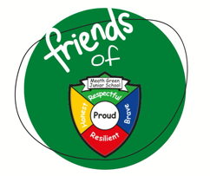
Well what can we say..... What a term!!! With the help of parents/carers, teaching staff, sponsors and donations we have managed to raise...... drum roll please............ £5319 in this term alone...... Phenomenal!!
We started fairly quietly with a Mufti Day and then with a massive Crash, Bang and Wallop in the last two weeks with the new addition of the Christmas Fair and the time-honored Christmas Disco. We hope yourselves and your children have all had a good time; your generosity has been second to none and has helped us to raise more money towards refurbishing the floor of the adventure playground. The money raised also includes proceeds from the school lottery and also, we were lucky to receive money from the Co-op, which was started last term, and we received the funds a few weeks ago.
Money spent so far this term has been in the form of helping Year 3 to fund their Chinese Dragon Workshop and we also provided a Christmas chocolate lolly for all children after they enjoyed their Christmas Dinner last week.
All these events could not happen without our volunteers and helpers so ‘THANK YOU’ to everyone that has supported these events by giving their time and effort to make sure it all runs smoothly either at the event or behind the scenes, it is all invaluable. A little special mention to Chloe Spearman who I have unofficially named our Creative Director as she designed Santa’s grotto single handedly which was magical, so thank you Chloe.
This has been my first term back as Chair (I did it 10 years ago) and I have to say I am so thankful for my wonderful committee who are just as great as the amazing bunch I was lucky to have all that time ago. I want to show special recognition to Shelley Constable (Treasurer), Gemma Minick & Sam Wilby (Joint Secretary) without these amazing ladies these events would not even get started, so thank you from the bottom of my heart for all that you do, it is so appreciated. We are always looking for enthusiastic people to come and join in with our madcap ideas so if you would be interested, please get in touch, I promise there is not a lot of work involved but a whole lot of fun to be had and definitely new friends to be made!
Here’s to a fantastic Spring term with hopefully a few more surprise events, watch this space!
Merry Christmas everyone and I hope you have a restful time.
Mandy (Chair of Friends)
Drop-off and Pick-up at MGJS
Can I please ask that when you drop-off or collect your children from school you always park in appropriate places. I am receiving a growing number of complaints from our neighbours where there have been instances of parking in driveways/across driveways/on verges/on corners of roads. There have also been times where verbal abuse has been used. Whilst I realise this is a small number of people can we please call out behaviours we are not happy with and are against our school values. Thank you for your support here.
School Crossing Patrol
Surrey County Council are still recruiting for a school crossing patrol person. If you or someone you know does have the capacity for this position, can you please direct them to SCC. There is a white board with information relating to this on Meath Green Lane by the school swimming pool gate.
School Uniform
Just a quick reminder that all pupils should be in the correct winter uniform after the holidays. Can we please also ask that they have a warm winter coat to wear (named) when they go out onto the playground and when they leave at the end of the day.
Sporting Fixtures (2nd half-term)
The girls' football team had a busy term with lots of matches. We played Earlswood in a mini tournament at their school. It was a good chance to try new teams and play against some really good players. We have been practising our skills at football club, especially shooting and dribbling with the ball. We are looking forward to more games in 2025. By Siena 6T

Year 5 SSFA Cup 2nd Round football match – written by Noah and Cameron 5M
In the second round of the cup, we played Cheam Common School. We were very positive that we could win. They scored first but we did not lose our spirit and we kept going. We missed a lot of chances but won the game 4 – 2. The scorers were Josh (2) and Cameron (2).

Year 5 SSFA Cup Quarter Final football match – written by Luke and Noah 5M
We played well in this game and made lots of chances. The passing was good and our defence was solid. They didn’t have many chances. We were unlucky not to win 10 – 1 because we made so many chances but the final score was 6 – 1 and we were through to the Semi Finals! Goal scorers were Cameron (2), Josh (2), Jaxon, Stanley. Man of the match: Luke.
Year 6 RRSPPA Football Tournament (Year 5 team) – written by Stanley and Josh 5B
At the start of the tournament, we didn’t have a lot of time to warm up and the games came quickly. Unfortunately, we lost the first 2 games. Some of us were annoyed at first but we pushed through and were determined not to let it stop us. We came 3rd in our ground so we progressed to the plate competition. After that we kept winning and winning. I scored against Lime Tree in the Quarter Finals to put us through to the Semis. We won the Semi Finals 3 – 0 and got through to the final. The final was a hard match but we played well and Stanley assisted Josh to score the winning goal and we won the plate trophy, an amazing achievement.
Year 6 SSFA Cup 1st Round football match – written by Dexter and Carl (6T)
In the first round of the cup, we played St Mary’s Oxted. It was an exciting match as we were playing 9 a side when we usually play 7 a side. Although it was a tough game, the boys gave it their all. After a hard first half, with a score of 0-0, all the boys were out of breath but the team knew they had to play better. The second half started with a bang with super Cameron putting us in the lead. After that, the opposition played their game and equalized to make it 1-1. We played with all our might, until super-sub Lenny came on and changed the game, scoring a deflected goal to win the game 2-1 - with Cameron man of the match. COME ON YOU GREENS!!!!

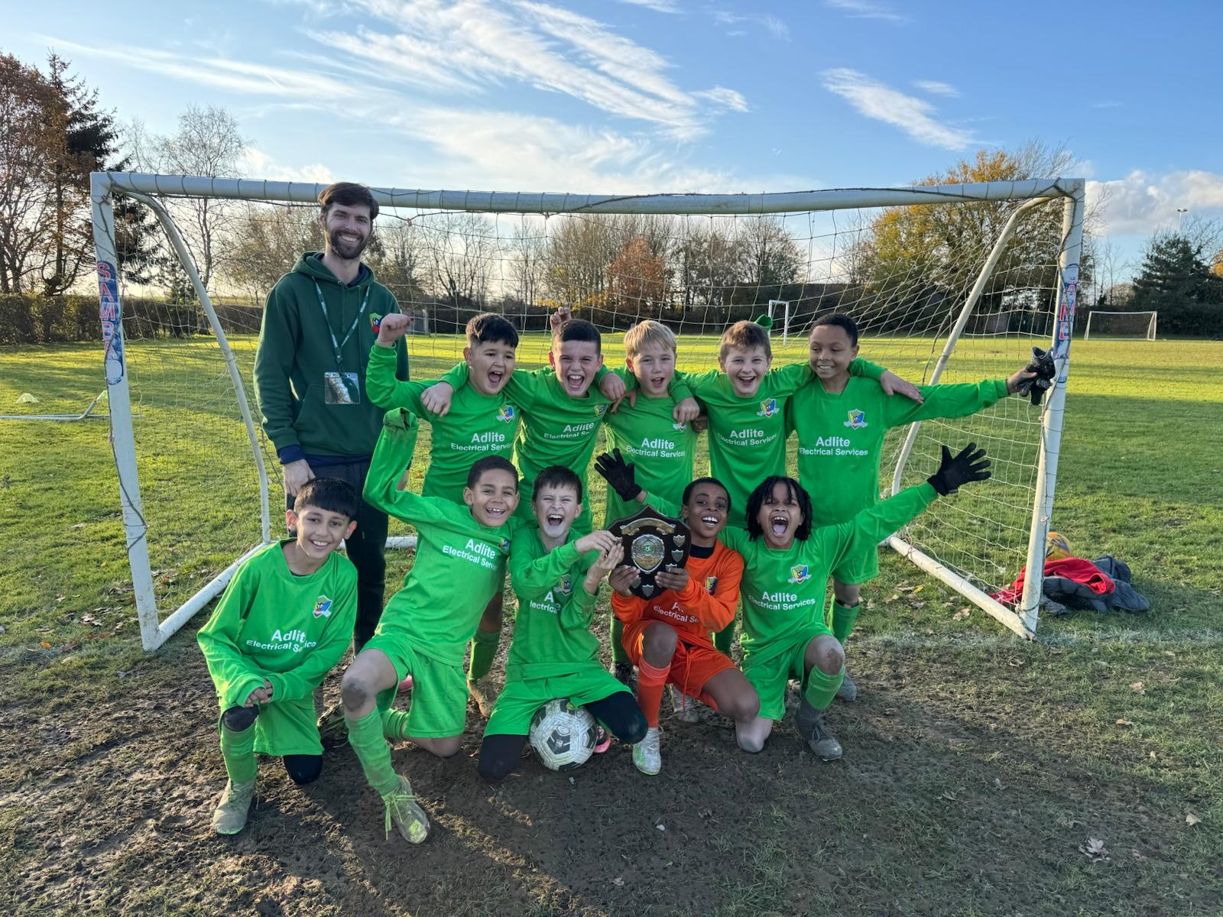

FYI – Mr Dann in Year 4 is taking part in a television quiz show on Saturday 4th January 2025. The show is called Limitless Win with Ant and Dec. Please tune in and see how he does……

KEY DATES: Please see attached January 2025 Flyer

Have a fabulous Christmas and see you in 2025!

