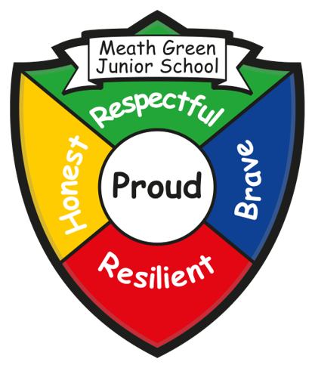
Meath Green Junior School Newsletter
Greenfields Road, Horley, Surrey. RH6 8HW
Tel: 01293 784298 Website: www.mgjs.org
Email: info@mgjs.org
Headteacher: Mrs Serena Beasley (s.beasley@mgjs.org)
What’s been happening……
It has been a very busy half term, packed full of learning – from the amazing ‘Wow’ days where your children begin to be immersed in their topics to the other areas of the curriculum which build on prior learning and experiences. We have had No Outsiders Week, Zones Week, Y5 Olympics, Y6 Bikeability, School Parliament Meetings, Y3 Stone Age Day, Feeling Good Week, Dyslexia Awareness Week to name just a few! The pupil’s commitment to learning has been incredible! Thank you also for your support with donations, dress up days and cakes – it is all very much appreciated.
As you can see the new front entrance is near to completion and through half-term, we are having our new modular classroom delivered. Both have been a longtime coming!
I also asked you to complete a survey following our parent consultations – thank you for doing this and I will send out a date for the parent forum meeting after half-term. This is just a chance to discuss the feedback and plan next steps.
We have also had a visit from Ofsted earlier this month – the report will be made available to you when it is published towards the end of November.
All that is left for me to say is have a lovely half-term – all important dates for the next half-term are at the end of this newsletter.
Thanks again – Serena Beasley (Headteacher)

Parent/Teacher Consultations
It was lovely to see so many of you during the parent consultations. Thank you also for the lovely comments about the House Captains – they did a great job!

Harvest donations to Crawley Open House and Horley Food Bank
Thank you for your very kind donations to support both charities.

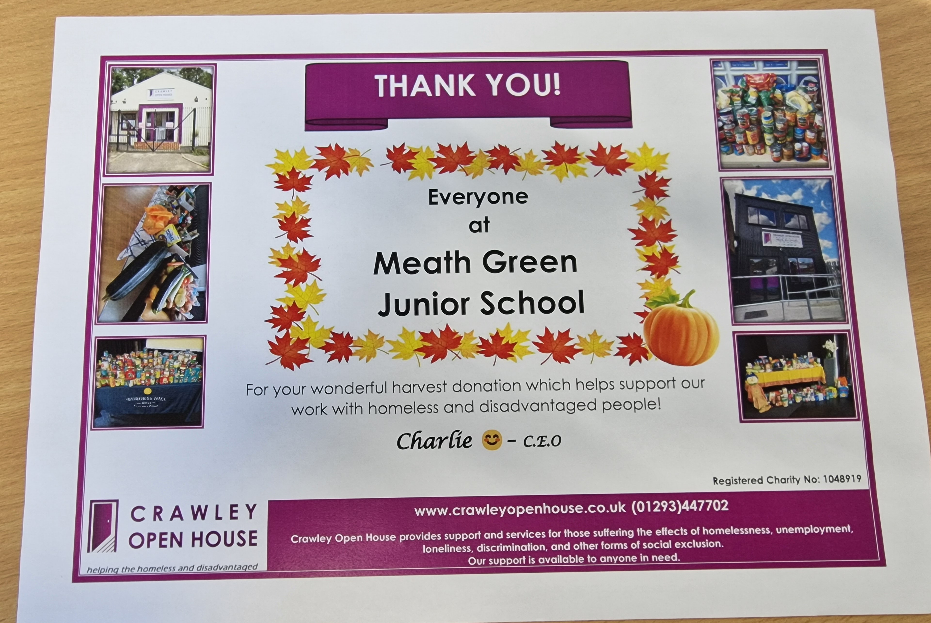

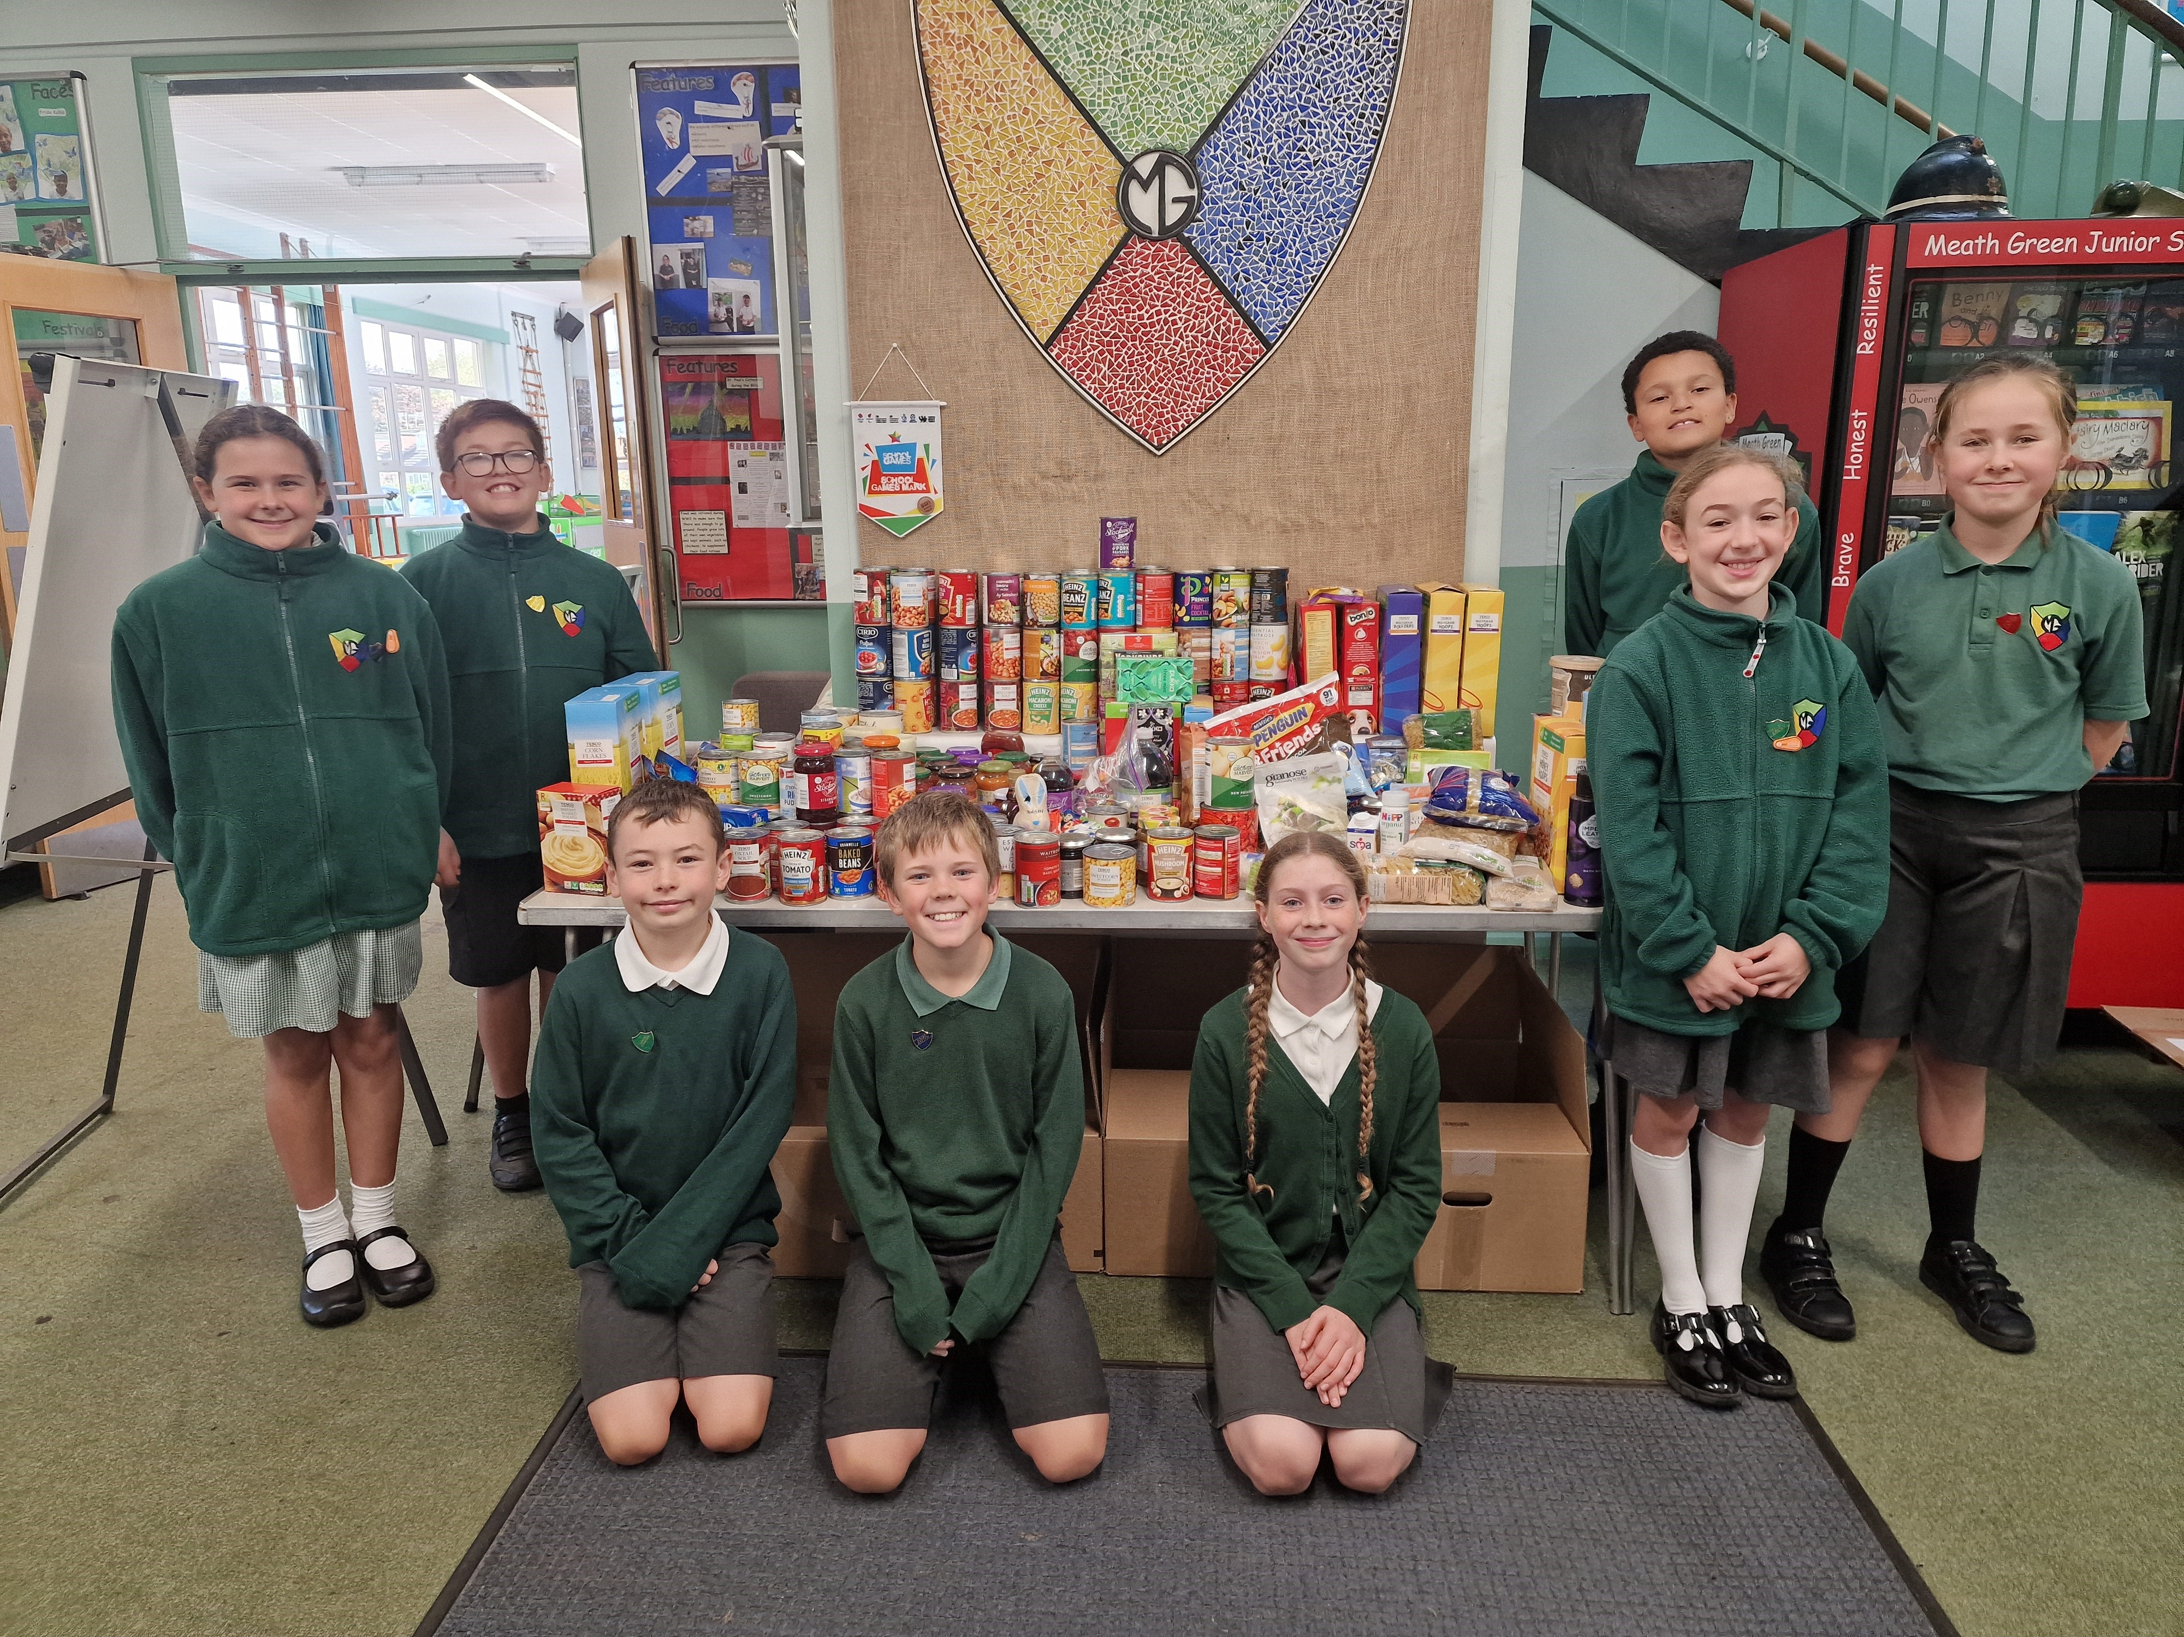

Book Fair
One of the best attended book fairs we have had – thank you! In total your children (with your help!) spent an incredible £1,290 on books! This will mean that, as a school, we will be able to replace some well-thumbed books on our library bus – Destination Imagination. Thank you.
School Uniform
We would like to remind parents that winter school uniform will be required when returning back to school after half-term. You will find the list of winter uniform in your child’s home/school diary or on the school website.
Sporting Fixtures (1st half-term)
We have had a very busy fixture timetable this half-term – please see the results below!
Boys Trafalgar v MGJS on Friday 11th Oct (Surrey Schools Football Association U10 cup match). We lost 6-1.
Boys Sandcross v MGJS on Wednesday 16th Oct. We lost 8-1
Girls Sandcross v MGJS on Thursday 17th Oct. We lost 3-0
Boys MGJS - Y5 3rd place in HLP tournament Friday 18th Oct
Boys MGJS v St Joseph's Monday on 21st Oct. We won 2-0
Girls MGJS v Hurst Park (Surrey Schools Football Association U11 Girls cup) – Report by Siena Y6
Yesterday we played a football match against Hurst Park School. This was our second match after losing to Sandcross last week. Sandcross are good and always tough to play. We lost 3-0 and wanted to do better this week. When we saw Hurst Park arrive, I was worried and nervous and didn’t think we had a chance. However, it was a close game and we all played really well. Izzy and Lilly stopped the other team getting through and Zoe nearly scored a few times. Sadly, we lost 1-0 in the end, but we learnt a lot and will do even better next time.
Up-date on requested zebra crossing on Meath Green Lane
Unfortunately, Surrey County Council have made the recent decision to not put a much-needed zebra crossing on Meath Green Lane. As you can appreciate, we are very disappointed with this decision as this term there have been some very near misses with pupils crossing the road to school or going home. They have also not managed to recruit a school crossing patrol person. After half-term I am meeting with a parent who has been instrumental in pursuing the crossing – we are going to plan how we are going to move forward. The children in School Parliament are also very keen to get involved and have previously written to the local MP. I will, of course, update you on any progress made.
KEY DATES
Monday 4th November – Back to School
Wednesday 6th November – 12 Y6 Pupils to Horley War Memorial for Remembrance Service with British Legion
Thursday 7th November – 9.00 am – 10.30 am - Open Morning of prospective Y2 parents
Monday 11th November – Anti-Bullying Week
Tuesday 12th November – Odd Socks Day
Wednesday 13th November – 6.00 pm MGJS Friends Meeting
Thursday 14th November – Whole School Flu Immunisations
Friday 15th November – Children in Need
Monday 18th November – Y4 Egyptian Wow Day
Thursday 21st November - 9.00 am – 10.30 am - Open Morning of prospective Y2 parents
Friday 22nd November – MGJS Friends MUFTI for Christmas hamper donations
Friday 29th November – INSET Day – school closed
Tuesday 3rd December – NSPCC Speak Out Stay Safe workshops for Y5/Y6
Friday 6th December – 11.00 am Christmas Tree Festival at Horley Methodist Church
Friday 6th December – 3.30 pm – 5.30 pm – MGJS Friends Christmas Fair
Monday 9th December and Tuesday 10th December – Y6 Height and Weight
Wednesday 12th December – MGJS Christmas Dinner
Monday 16th December – Friends Christmas Disco
Wednesday 18th December – Y3/4 Christmas Performance 10.00 am, Y5/6 Christmas Performance 2.00 pm
Thursday 19th December – Y5/6 Christmas Performance 10.00 am, Y3/4 Christmas Performance 2.00 pm
Friday 20th December – Break-Up for Christmas at 1.30 pm

From all at MGJS - Have a lovely half-term!

