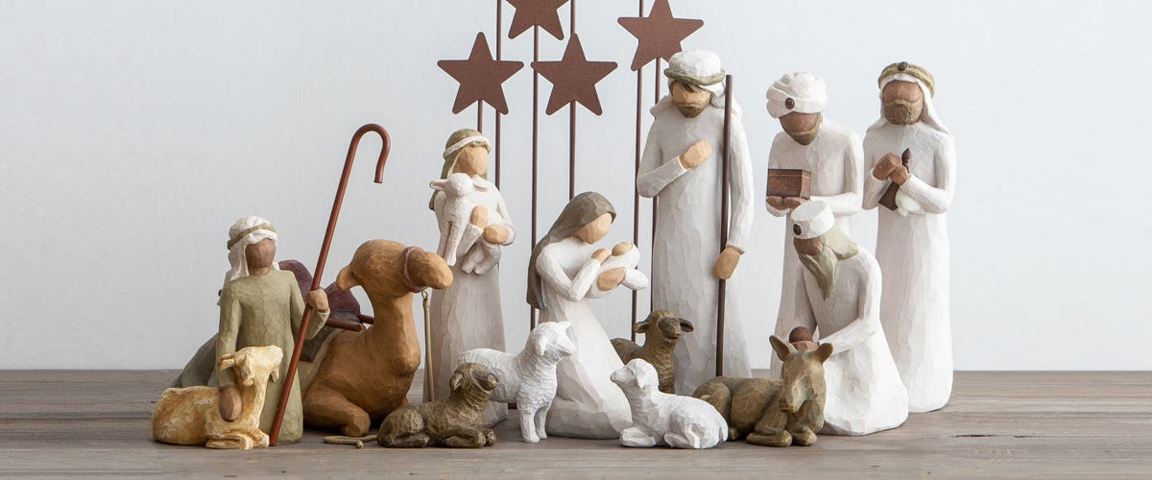

KEY DATES 2024
Tuesday 2nd January 2024 –
Back to School

Monday 8th January –
Y5 Wonderdome

Tuesday 9th January - Y4 Wonka Cinema Trip

Thursday 11th January –
Whole School Pantomime ‘Beauty and the Beast’

16th and 17th January –
Y6 Height and Weight

Monday 5th February – Children’s Mental Health Week

Wednesday 5th February – Y6 Junior Citizen @ Woodhatch

Tuesday 6th February –
Safer Internet Day

Thursday 8th February – Friends Valentines Bake Sale

Friday 9th February – INSET DAY and Break-Up for Half-Term

Monday 19th February –
Y3 Dragon Workshop

Tuesday 20th February and Wednesday 21st February – Y6 Parents Evenings

Monday 26th February/Tuesday 27th February – Y5 Bough Beech

Friday 15th December 2023
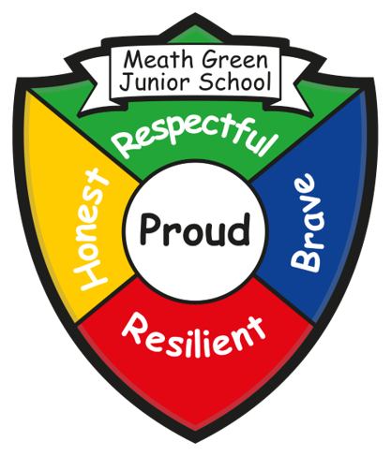
Meath Green Junior School
Greenfields Road, Horley, Surrey. RH6 8HW
Tel: 01293 784298 fax: 01293 822359 www.mgjs.org
Email: info@mgjs.org
Headteachers:
Mr Patrick Amerio (p.amerio@mgjs.org) Mrs Serena Beasley (s.beasley@mgjs.org)
Dear parent/carer
We have had a great run-up to the end of a very busy autumn term! So many great learning opportunities from Y3 being Stone Age people, Y4 Egyptians, Y5 Greeks and Y6 WW2 evacuees. The children have worked incredibly hard and we are proud of their many achievements.
We would like to wish you a very happy Christmas and look forward to another learning packed spring term. Thank you for your continued support.

Christmas Carol Services
Thank you to everyone who attended our Christmas performances this week – a memorable end to this term. The children sang beautifully and delivered important information about Christmas. The pupils chosen charities of Crawley Open House and St. Bart’s Church Roof Fund will share £330 which you kindly donated at the end of the performances. Thank you for your continued support.
Christmas Dinner Day and Christmas Jumper Day
Last Wednesday was our Christmas Dinner Day – the children enjoyed a very festive lunch with Christmas music, Christmas jumpers and hats! Thank you to the kitchen – Nicky, Sue and crew, thank you also to the Friends for providing the children with a chocolate bar at the end of the day.
ZOR Christmas Fair
Wow! Wow! Wow! Thank you so much for attending the Zor Christmas Fair last Thursday, we were shocked at how busy it was, we were definitely not expecting such a high attendance, so thank you for spending your time supporting the school.
We have finally added up the money taken, deducted expenses and we have made a staggering £1134.56

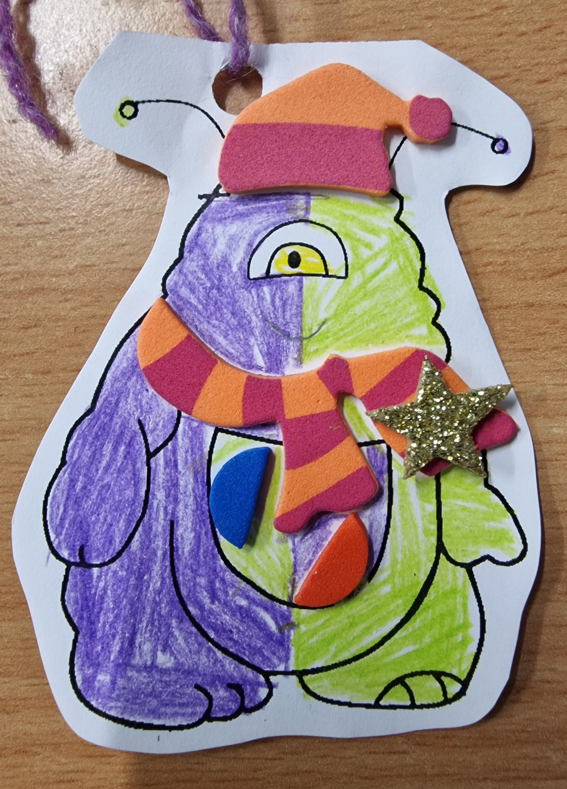
As you will be aware there were about 8 stalls which were run by the year 6 pupils, and their contribution to the total equalled £379.19. Well done to all the children who put so much time and effort into their games, and made the fair even more of a success.
This money, as well as a very generous donation from someone who wishes to remain anonymous, means that we can provide all of your children with even more resources for the Zones of Regulation. We will be creating something very special in our sensory garden for everyone to enjoy. We will keep you updated with this, it will be a project to start in the spring when the weather warms up a bit more.
Once again thank you for all your support, we hope you enjoyed the fair and we would like to wish you all a very Happy Christmas, enjoying whatever makes you feel happy.
Farewell and Goodbye…
We are sad to be saying goodbye to two members of staff this term. Firstly, Mr Bunn who has held many roles within the school – support staff, premises manager, school crossing patrol and forest schools to name a few! Thank you for all you have done for the school – you will be missed but we wish you all the best for the next chapter in your life. Secondly, Mr Archer, our sports coach. Thank you for supporting all our pupils with their sports and activities – the children will miss your enthusiasm and smile. We wish you the best in your new school.
Christmas Card Competition
Thank you to all the children who designed a Christmas card for our local MP’s competition this year. We are very pleased to announce that for the third year in a row the winner has come from MGJS! Congratulations to Tessa in Year 6 who created a very witty mince-spy design – thank you to all of you who came out in force when it came to the voting! Tessa and her family will be enjoying a cup of tea and a slice of cake with Claire Coutinho MP at the House of Commons in the New Year.
Snapper from Waitrose
Waitrose in Horley have very kindly donated a number of ‘Snappers’ from the Waitrose Christmas advert. Each teacher selected one member of their class who has been an absolute superstar this term – in relation to positive learning behaviour, following our school values and being a great team member in the class. In 3TM – Louisa, in 3R - Coraline, in 3S - Giuli, in 4C – Chloe, in 4M - Khavhiish, in 4D - Louie, in 5B – Henry, in 5L - Aidan, in 5J – Isabel TB, in 6G - Carmella, in 6T – George M, in 6D – Lyra. Congratulations to all our winners – what a lovely end to the term.
Autumn term Book Raffle Winners - Congratulations to our book raffle winners this term:
Dindy and the Elephant by Elizabeth Laird – Naomi 4C
The Case of the Lighthouse Intruder by Kereen Getten – Mia 5J
The Blunders by David Walliams – Oscar 5B
The Wonder Team by Leah Williamson – Bianca 3S
Impossible Creatures by Katherine Rundell – Lyra 6D
Space Band by Tom Fletcher – Lakshit 6G
Tyger by SF Said – Jack 3R
City of Stolen Magic by – Nazneed Pathak – Jasmine 5J
While the Storm Rages by Phil Earle – Khavhiish 4M
Paddington at the Palace by Michael Bond – Jessica 5B
Bunny vs Monkey by Jamie Smarts – Ruby 5J
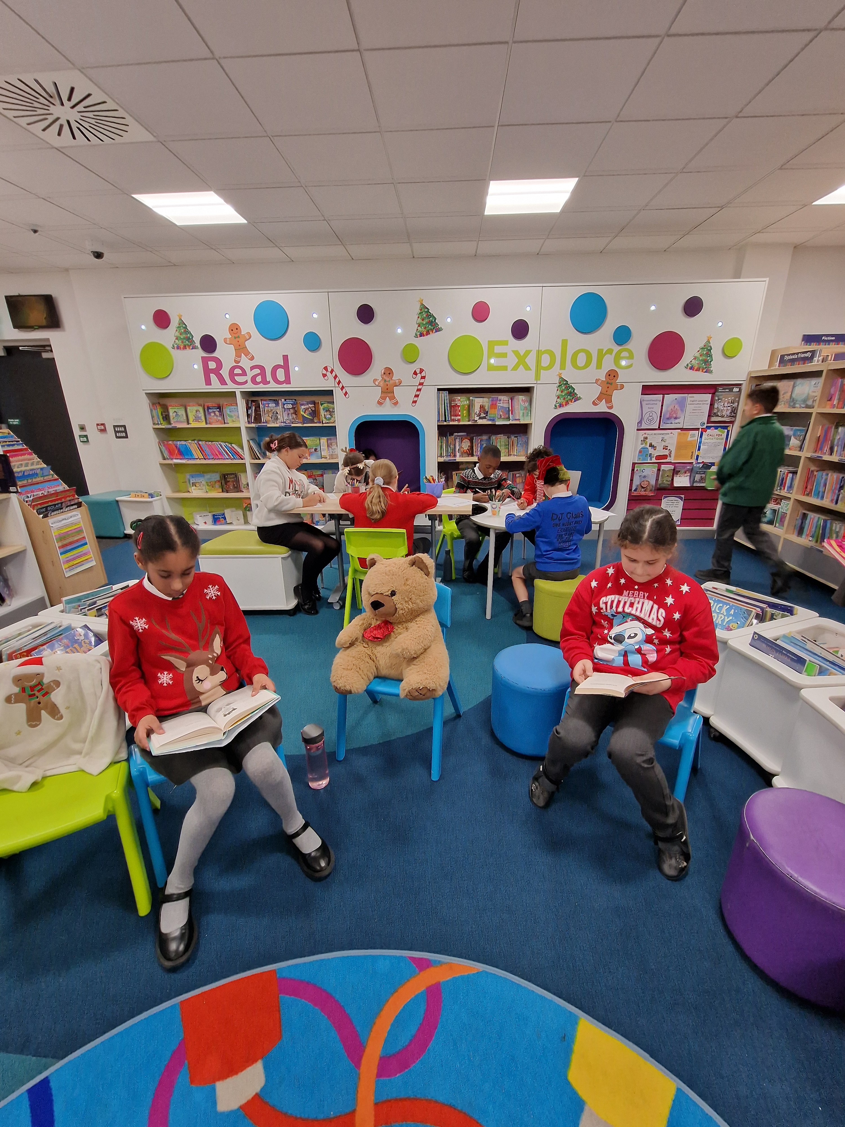
The Best Ever Baking Book by Jane Bull – Jacob 4D
Book Raffle Trip to Horley Library
The winners of the Book Raffle had a great trip to Horley Library earlier this week. This trip was for the children who won the book raffle last term. The librarian was so impressed with their participation in the discussion about the library and the knowledge they already had. Activities and reading then filled the rest of the trip. Thank you to Horley Library and we look forward to coming back in the spring term.

New addition to the MGJS family…
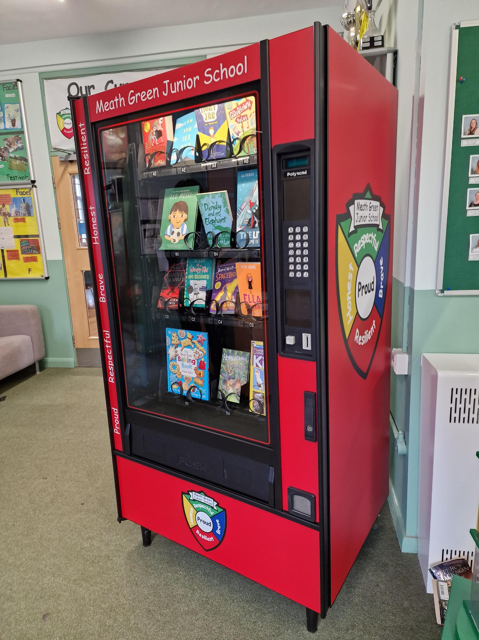
You may have already heard (as the children are super excited!) but we have a book vending machine in school. We would like to thank our three donors who have enabled us to purchase this fantastic machine. As you are aware, we are really passionate about promoting a love of reading across the school. We will be introducing a ‘reader of the month’ from each class. At the end of each month one child per class will be awarded a ‘reader of the month’ certificate. They will then collect a token from us in assembly which they can then use at the book vending machine. These winners can choose from a range of books which they will keep – the book does not need to be returned! Reader of the month will begin in January 2024!
Reading over the Christmas holidays
We would please ask that you encourage your child to keep up with their daily reading through the Christmas break – it is such a key skill for the children to access the curriculum and a daily dose keeps them from falling behind. If your child reads a good book over the holidays please encourage them to e-mail me, s.beasley@mgjs.org with the book name – this can then be purchased for the vending machine. Thank you.
Autumn term from our pupils
Year 3 by Bisan 3R and Dhilan 3TM
This autumn term we have done lots of fun things. We enjoyed our topic, 'We Will Rock You' the most, especially our WOW days! On our first WOW day we met a man named Flint. We played Stone Age games and handled Stone Age artefacts. One of the games was mammoth hunt where we had to chase the mammoth into the marsh. Then we played an ancient board game where we had four counters and had to see who could get theirs to the end first. It was a bit like Ludo! On our Bronze Age WOW day, we made flint knives out of soap and we used a lolly stick to knap the soap into the shape of an axe head. We did some digging inside coprolites, which is fossilised POO! We found lots of things like; berries, nuts, flowers, scales, teeth etc. We also completed our roundhouses, and this is what we did. We weaved the twine (which is like a strong piece of string) and added gluey newspaper (which was the papier mache). These were the best bits of term 🙂
Year 4 by Anya and Chloe
During the first term, we had a brilliant time in Year 4. We started off the year with our topic, Ancient Egypt which we all loved and we had the best Ancient Egyptian wow day. This was linked to our book "There's a pharaoh in the bath" and wrote a diary entry about Sennapod which is a mummy that came to life! We learnt lots of facts about the River Nile and pyramids and we really enjoyed learning about mummification. Here are some steps... (Not in order) First you have to wash the body. Put the organs in canopic jars.
In DT we have been making marble mazes and death masks. When we made our mazes we worked together to cut the wood ourselves. We used real saws to cut our wood. For our death masks we got given shiny paper to create the mosaic; it was tough.
In our art we have been drawing line landscapes and we learnt about an artist called Piet Mondrain; he was an abstract artist! We also loved creating our animal symmetry.
In science we have loved learning about animals, and their habitats. We created our multi adaptive animal and wrote our own non chronological reports about endangered animals.
We finished off the year sewing our puppets!
Year 5 by Rubie and Iris
We have loved Year 5 so far! We were a little scared to begin with as it has been a massive jump from Year 4 to Year 5. Our Greek wow day was so exciting – we got to try Greek food which was surprisingly good! We also made some Greek bread which was very fluffy. In Science we have completed lots of experiments – we carried out lots of tests on filtering water. One of our favourite things has been the DT project because we have learnt how to use different tools – we got to go foraging too! We are having so much fun in Year 5.

Year 6 by Lilly and Oscar
We were excited and a bit nervous to start Year 6 in September. We began learning about WW2 straight away and went on a visit to Newhaven Fort in our first week! We experienced an underground bunker and heard the sirens wailing. There was a canned egg from WW2 which you could hear rattling in its tin. We were glad we had our own packed lunch!
Learning about Anne Frank was really powerful as she was our age when she went into hiding. We enjoyed presenting our topic work in different ways such as a jigsaw, timeline and little doors.
A highlight was when we invited some of our older friends, grandparents and veterans to a VE Day tea where we shared our work and listened to their stories and experiences of the war. One of our visitors was 105 years old! Some of them had been evacuated. We also showed them our home learning craft which included helmets, Anderson shelters and spitfires which we had created as part of home learning. We also became journalists and wrote our own reports on the Blitz.
We have also enjoyed various Science experiments including making a pressure plate to turn on a light bulb and investigating circuits.
We have marked different weeks this term such as Anti-bullying where we coloured socks encouraging people to say what was going on and ‘No Outsiders’ where we thought of imaginary characters to celebrate our differences.
Our highlight of the Autumn Term has been designing our own Christmas stockings which we have sewn for a family member. Everyone has loved this – even the teachers!
Sport Autumn Term 2023
Another very busy and successful sporting term.
Football
Congratulations to the Yr6 football team that won the Horley Schools football tournament.
The format of the competition was a league, where each school played each other once. Having won every game convincingly, they finished top of the league, unbeaten and only conceding the single goal.
It was a well-deserved victory as in Yr3 they finished second from bottom, in Yr4 they finished third from bottom, in Yr5 they were second. This year they won! Great credit to a bunch of boys and girls who worked hard to improve. Getting better never stops
Girl’s Football by Emily and Lily Year 6
Our football team has had an amazing start to the season. We beat St. Joseph’s 4-0 with amazing goals from Rosie and Emily. We had a close 2-2 draw with Sandcross with brilliant defence by Lily and Molly. Last week we won the District Girl’s Tournament beating some of the best teams in Reigate and Banstead. We are now the champions!
Cross-country
Unfortunately the Horley Schools cross-country was postponed due to bad weather, we hope that it will be rearranged for next term.
Netball
We have had a wonderful term playing netball, the Year 5 & 6 children have come on leaps and bounds. There are currently only 8 children in the club, however they have put their all into learning new skills and earlier in the term they had their first match against Reigate Priory, which they won! This has given them the well-deserved boost that they needed. We have a lot more matches next term and we are even hosting a tournament, so that will be brilliant fun for them all. We would also love to welcome new or returning players back to the club so that we can have more variety, so if your child has an interest in Netball, please sign them up, it is a fantastic skill to acquire.

Help us if you can!
If you are fortunate enough to have too many presents this Christmas, we are here to help. As Santa delivers lots of new goodies, we would welcome donations of any old, unwanted games that would be loved at MGJS. Any board games (as long as they are complete and not missing pieces), chess sets, Guess Who?, Monopoly, Connect Four, Lego etc would be fantastic, as we would love to provide the children with more things to do in class on days when it is too wet to go outside to play. So, if you are looking to clear some space after Santa has visited, please drop any games into school when we return in January. They would be greatly loved in their new home. Thank you.

Uniform
It has become quite noticeable this term that children are not always in the appropriate uniform for school. Please can we ask you to check in the home/school diary as to what is our winter uniform. Also can you please ensure that your child does not have painted nails and that they are not wearing jewellery – small studs in ears are acceptable.
Parking and Drop-off/Collection
We have had a number of issues raised from our neighbours this term in relation to driving up on the grass verges during collection and drop-off. This is a real safeguarding issue in relation to keeping the children of the school safe at all times. Please refrain from doing this at all times. If there is an event at school and you can walk please do as this will help with the situation.

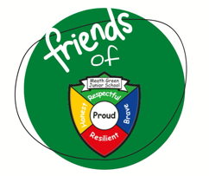
Message from Friends of MGJS
Our 2023/24 fundraising events started off the Welcome Back Picnic – this was a lovely, relaxed evening which saw Mrs (& Mr) Beasley and Mr Amerio cooking up a storm behind the BBQ. It was great to see so many families coming together to enjoy the last of the summer evenings. Our fundraising efforts continued with 2 mufti days: one for‘Feel Good’ week and the other for the fantastic raffle Hamper donations. Bags2School, in mid-November, was our best one yet (Thank you!) and then we rounded the term off with our Christmas Raffle and Disco’s. As always, the support from our families has been brilliant and together, we have raised just over £1700 this term. THANK YOU!
School events are one way to support our fundraising efforts – another way is SPONSORING the events. We have a few coming up and sponsorships help us to cover costs. Laura will be in touch with past sponsors shortly, but if you run/work for a company that would be interested, please do get in touch (friends@mgjs.org).
We are thrilled to have been chosen as one of the Co-op Local Community Funds for 2023/24.
Every time you shop at the Co-op you can help us raise funds by selecting us as your chosen cause. Please share this with families and friends all over UK.
Our cause profile page is https://membership.coop.co.uk/causes/79682


UPCOMING EVENTS
8 Feb – Bake Sale
28 Feb – Termly Meeting
6 March – Movie Afternoon
28 March – Make the Rules Day
17 April – Bag2School
23 May – Colour Run
In January we also need to hold an Emergency General Meeting (EGM), in order for our Treasurer, Sophie, to formally step down and to vote in our new committee members. Date to be confirmed. On that note - I’d like to thank Sophie Jones for the time she has given The Friends - without her everything would have been that little bit harder. She helped in more ways than ‘just’ looking after the money. You have been amazing Sophie, THANK YOU!
If you are interested in getting involved, in any way, with The Friends, please do get in touch (friends@mgjs.org).

Christmas Wellbeing Tips
If you find Christmas a difficult time of year, the link below has some tips to help you cope.
Different things can help us at different times, depending on our situation and how we're feeling. Try some of these ideas and see what works best for you.
https://www.mind.org.uk/information-support/tips-for-everyday-living/christmas-and-mental-health/christmas-coping-tips/

Mental health doesn’t take time off at Christmas, and with all the added stresses that can come with the festive season it’s very important to care for your wellbeing. Follow our Christmas tips to support your wellbeing over the festive season.
Be active
Are you feeling tired and exhausted in the run up to Christmas? Research suggests keeping active can help beat tiredness. Why not try a walk around a Christmas market, a brisk stroll around the countryside or even ice skating?
Take notice
Have too much to do before Christmas? Often we can be so focused on a growing to do list that we forget to pay attention to what is happening now. Take notice of your surroundings – wrap up warm and pay attention to all the seasonal smells of freshly cut Christmas trees and logs burning on the fire.

Keep learning
Stuck for Christmas present ideas? Why not learn a new skill? It can not only improve your wellbeing but also make for exciting, personal Christmas presents. Save Santa’s elves a job or two!
Give to others
Feeling stressed this Christmas? Christmas can be a great time of year to do something for someone else. It doesn’t have to break the bank – something as simple as a smile or a ‘thank you' can help with your own wellbeing as well as theirs.

Connect
Feel lonely this Christmas? Christmas can be a tough time of year. Talking to and interacting with the people around you, whether that be family, neighbours or a friendly ‘hello’ to the person standing in the queue behind you at the shops, may help.
Keep your expectations of the festive period realistic
Many of us have a perfect vision of what the holidays should look like, and are disappointed when they don’t live up to their expectations. Remember, nobody has a perfect holiday or a perfect family, so don’t pressure yourself to live up to unrealistic standards!
Coping with anxiety
Christmas parties and events can be stressful if you struggle with social anxiety. Don’t feel pressured to say ‘yes’ to every invitation – you are allowed to decide which festive events and traditions are more important and enjoyable for YOU, and decline the activities which cause you unnecessary stress.
Christmas prep causing stress?
Christmas can be a huge source of stress, and it’s easy to feel there’s too much to organise, or too much pressure on you – but don’t hesitate to reach out for help if you need it. Ask a friend or family member to help you with chores, or contact local mental health services who can offer support, advice and resources.
Take some ‘me time’
The holidays can be an overwhelmingly social time, with gatherings of family, friends and colleagues. Don’t forget that you’re allowed to set aside some ‘me time’ as well, such as curling up to read a favourite book or watch a Christmas TV special.

Just a final reminder that all staff will have their out of office notifications on their e-mails at the end of today until Tuesday 2nd January 2023. If you need to contact a DSL (Designated Safeguarding Lead) with regard to welfare or safeguarding then please contact the e-mail address dsl@mgjs.org

Thank you for your support this term. We wish you a Merry Christmas and a Happy New Year – see you in 2024!

